Northside Community Church

Newsletter
April/May/June 2019

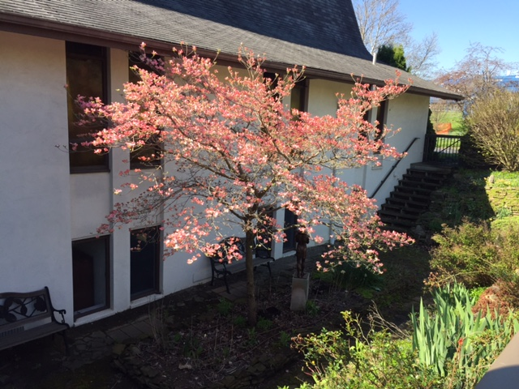

929 Barton Drive
Ann Arbor, MI 48105

734-662-6351
Northsidecommunitya2@gmail.com
Pastor: Rev. Terence McGinn

Here’s what’s happening at Northside:

Easter 2019
We had a Maundy Thursday service on April 18 at 6pm with 20 people attending.
We had 54 people in church on Easter Sunday.

Farewell Robby Baine
Robby Baine has graduated from UM Music school and moved to Arkansas for the summer to take part in an opera program. He held his graduate recital at Northside on April 30. We provided a reception for him following the music. Note: Terry got a seersucker suit, shoes to match for Robby from Northside. Al and Sheree then got him a shirt and tie to match.

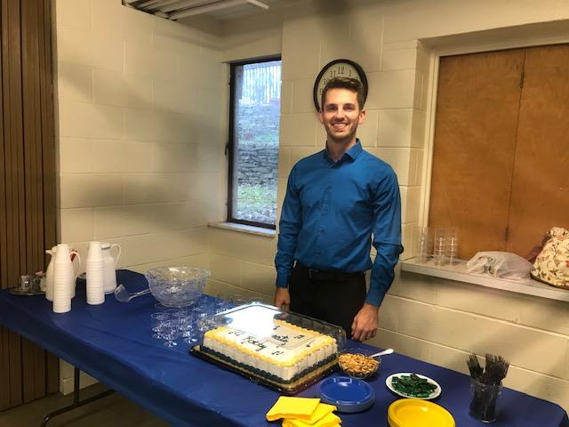

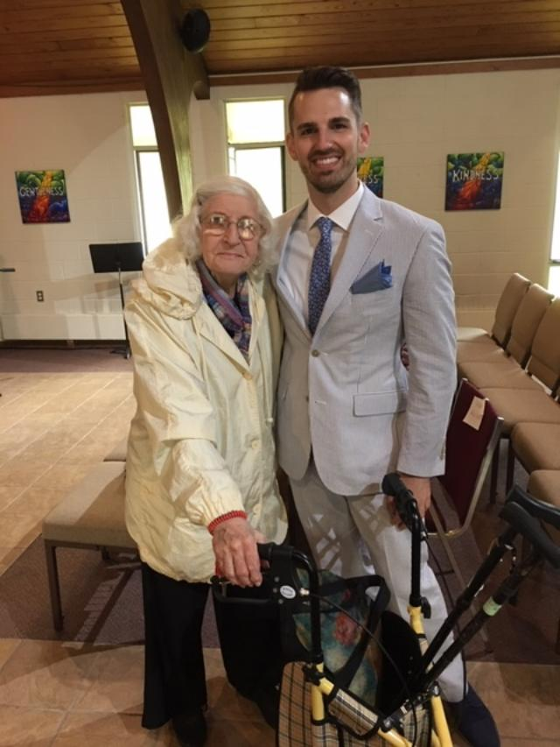

Esther and Robby

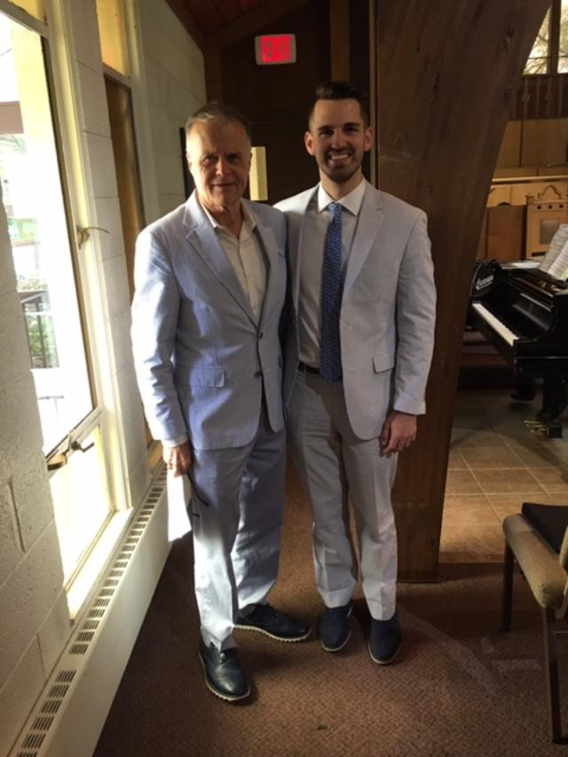

Terry and Robby match!
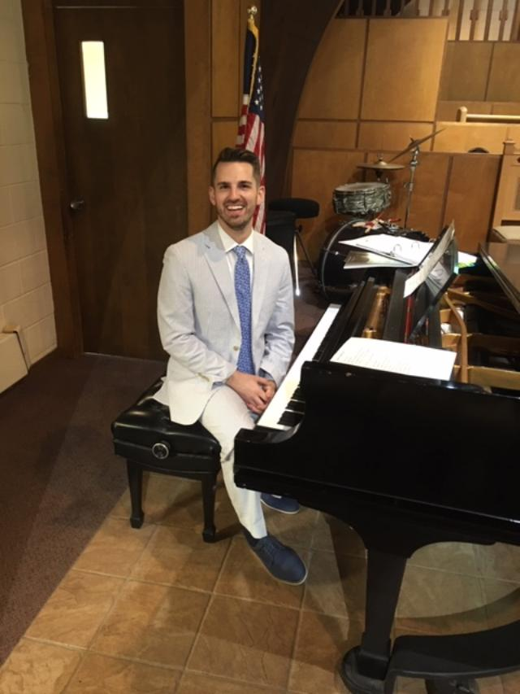

Spring Luncheon
Several women in the church went to a salad luncheon at First Baptist Church on May 2. Pictures from this event at the end of the newsletter!

Mark your calendar - Christmas in October - 2019
Our Women’s Prayer Fellowship will again host this event on October 19. We have invited back vendors from last year. . Stay tuned for more information!

Boiler
John Heiftje brought information to the board in May regarding the purchase of a new boiler. There will be a congregational meeting June 9 to vote on the proposal that the board is recommending. We will have a new boiler in time for winter!

NYC (Northside Youth Chorale)
This FREE program for kids in 4th to 6th grade ran for 6 weeks in February and March. There were 4 participants. They ended their time with a concert for parents. 2 of them joined us on the following Sunday for our worship service.

Happy Birthday and Anniversaries in April, May, June,July
April 1 Steve McTaggart
April 5 John and Sue Wurster - anniversary
Lloyd and Elizabeth Kitchens – anniversary
April 8 Mary Ellen Hagel
April 13 Paul and Tyler Clark
April 16 Andy Block
April 19 Esther Yost
April 29 Joan McTaggart
May 21 Andy and Sarah Block – anniversary
May 23 Anne Daws-Lazar
May 31 Al and Sheree Clark – anniversary
June 15 Jane Wild
June 18 Susan Bondy
June 20 Sheree Clark
July 26 George and Gloria Taylor anniversary

Missions
- This offering will start early June

Purpose
One Great Hour of Sharing (“OGHS”) is one of four annual offerings received by American Baptist churches. OGHS makes the love of Christ real for individuals and communities around the world who suffer the effects of disaster, conflict, poverty or severe economic hardship, and for those who find themselves refugees or displaced within their home country.

Your World Relief Committee
Have you ever wondered how the gifts that you give to the One Great Hour of Sharing offering get to the places where they are put to work? This is the responsibility of the World Relief Committee (WRC or “Committee”). The Committee’s purpose is to support, enable and encourage emergency relief, refugee work, disaster rehabilitation, and development assistance. The source of funds for this work is the gifts you give to the One Great Hour of Sharing offering.

History
Fifty years ago, during World War II and immediately following, Protestant churches made appeals for relief and reconstruction. In 1946, Bishop Henry Knox Sherrill, newly-elected Presiding Bishop of the Episcopal Church, set a goal of one million dollars per year for the Presiding Bishop’s Fund for World Relief. On nationwide radio, he challenged members to raise “one million dollars in one hour.” His impassioned challenge worked. During the first three years, Episcopalians raised $3.8 million.
In 1949, church leaders from several denominations formed an ad hoc committee to organize an appeal aimed at supporting the separate campaigns of American churches. While the post-war language seems a bit stilted, their joint statement in support of this effort is still remarkably contemporary:
“This nationwide united effort by America’s Christians has an importance far beyond the practical goal of fund raising. For this great joint program will not only strengthen the vitally important relief and rehabilitation work of the churches overseas, but will also prove to all the world how great is the power generated when Christians unite in a common cause.”
A cast was recruited from among the foremost dramatic and musical talent in the United States, including Gregory Peck and Ida Lupino, and a script was written under the direction of playwright Robert Sherwood. President Truman brought greetings. Major networks and many independent stations carried the program on Saturday, March 26 at 10 p.m., EST. The broadcast, called “One Great Hour,” closed with a request that listeners attend their local church the following morning and make a sacrificial contribution. No exact measure of income was possible, but it was estimated that more than 75,000 churches participated.
In 1950, the title “One Great Hour of Sharing” was used for the first time. A logo depicting a church steeple clock with hands fixed at eleven was also adopted. A series of six fifteen-minute radio programs was produced to promote the effort, but problems with radio stations brought disappointing results.
The next year, the name of the offering was changed to “One Great Time of Sharing.” In 1952, the name was changed back to One Great Hour of Sharing, and has remained so ever since. By 1954, the announced goal for all giving to One Great Hour of Sharing reached eight million dollars.
From the beginning this has been an ecumenical effort. As denominations changed and merged, One Great Hour of Sharing has varied from eight to twenty-nine participating communions. Currently, the One Great Hour of Sharing committee officially comprises nine Christian denominations: American Baptist Churches USA, African Methodist Episcopal Zion Church, Church of the Brethren, Christian Church (Disciples of Christ), Cumberland Presbyterian Church, Presbyterian Church (U.S.A.), Reformed Church in America, United Church of Christ, and Church World Service. The Christian Church (Disciples of Christ) calls the offering Week of Compassion. In various ways, all work in cooperation with Church World Service, the relief, development and refugee assistance arm of the National Council of the Churches of Christ in the U.S.A.
At times, One Great Hour of Sharing has been coordinated with the Roman Catholic Bishops’ Fund Appeal for Overseas Aid and the Jewish Passover Appeal. Efforts were made to combine forces to attain the endorsement of the Advertising Council. Joint approaches were made to editors and program directors of radio and television. Free time and space were donated. Today, changes in FCC guidelines have all but eliminated this promotional opportunity. Yet, the offering survives, even thrives, in local congregations.
The purpose of One Great Hour of Sharing has remained the same: to collect special gifts to assist
those in need. Contributions to One Great Hour of Sharing make a difference in the lives of people. Church World Service, with overseas partners are often the first on the scene following a disaster of natural or human origin. The needs of the people are identified and priorities are set to bring long-term solutions that will improve the quality of life for individuals and communities around the world. One Great Hour of Sharing, nearly 50 years old, continues to respond to needs equally critical as when it was first created.

Mindfulness and Mental Health
May 2019
May is Mental Health Awareness Month. Mindfulness is the study of paying attention to the here and now. This means we are more aware of what’s going on in our thoughts, bodies and emotions. So to begin to be more mindful could be to just start with a mindful walk. Instead of dashing around on auto-pilot, slow down for ten minutes and pay attention to the physical sensations of walking. Feel your feet on the ground and the breeze on your body. Make it your walk, your movement, your choice for right now.
Next choose good mood foods. Pack your diet with plenty of fresh fruit and vegetables, which are proven to lift mood. Stimulants like sugar, caffeine, and alcohol can make anxiety worse, so try to cut back. Never skip breakfast. Drink plenty of water too. We need to drink about 8 cups of water a day. Even mild dehydration can make you feel lethargic.
Take positive action. Accept the things you can’t change in life and address the things you can. When you can take practical action to address the problem. For instance, find a work/life balance. Try to make working overtime the exception, not the norm. Check your to-do list before you leave work to leave the work behind! Then avoid checking your work e-mail once you are home. And really try to unhook once you are home. Intentionally find an activity that you want to do, not one you have to do.
Make sure you stock up on sleep. TV’s, laptops and smartphones stimulate our brains, making it harder to sleep. Try switching them off at least one hour before bed to create a calm space. If you are anxious about something, jot down your worries before bed to help clear your mind.
Try making a gratitude list. Write down as much as you can think of that you like about your life and yourself, however small. Take your time and aim for 10 things. If you feel down or worried, go back to this list and remind yourself of the positive.
Get physical. Regular exercise is proven to be effective in treating mild depression. Find the activity that fits for you and get moving. Take a friend with you to double the fun!
Also get your greenery fix. Go outside, enjoy the sun and the moon! Enjoy the rain and the shine, the warmth and the coolness. Getting outdoors can improve mental health and boost self- esteem. We are so blessed to live in an area with all of our trees and parks. So check them out.
Lastly, connect. Evidence shows that feeling close to friends and family helps us guard against sadness and depression. Ring the friend you’ve been meaning to call and accept that invitation to join us on Tuesdays at Noontimers-at noon! Bring a sack lunch and join us for what I promise will be a good, no a great time.
God gave us our church family, our biological family, the family we have chosen to love and cherish. Accept this Gift. That is the first and really only step we have to do to truly be mindful.
In God’s love and service,
Sheree Clark

**If you have an article or information to add to a future newsletter please email to Anne, or leave information in the office (church email:northsidecommunitya2@gmail.com)
Thanks to those who provided material for this newsletter

***If you would like to be on the prayer chain see Anne or Sheree

Northside Community Church Prayer Chain 2018
These chains are for both JOYS and CONCERNS!
When you have a need for prayer, please call Esther Yost at 7616145 first. She will start each chain and call Anne Daws-Lazar 734-649-7948. Anne will call Sheree Clark (313-910-1689), MaryRuth Hegerich and RoseAnna Hoxey. Sheree will call our pastor Terry (Terry’s # 734-834-0598)

Prayer Chain #1
Steve McTaggart - 973-0656
Sophie Farah - 665-0063
Holly Perry - 717-8797
Dennis Carter - 572-7312
Prayer Chain #2
Sue Wurster - 663-0064
Kathryn Stafford
& Steve Guerriero - 995-9322
Kathryn Goodson - 576-2355
Andy Block - 668-0222
Prayer Chain #3
Elizabeth Kitchens - 662-4190
Loumar Sondeen - 662-7335
Ellie Grinstead - 996-4457
Mary Ellen Hagel - 668-8069
Thank you for being part of this vital ministry of our church. Please call the next person on the chain promptly, if not answering, leave a message and call the next person. If you were not able to leave a message please call them again later. Thank you for your faithfulness. Updated 07/12/2018

Ministers: All the members of the Church
Staff:
Pastor Rev. Terence McGinn
Ministry Associate Dennis J. Carter, Sr.
Ministry Associate Sheree Clark
Music Director Kathryn Goodson
Chancel Choir Director............................................Paul Clark
Bell Choir Director Sheree Clark
Martin Katz Musician In Residence……………..Robby Baine
Holly Perry Vocal Intern……… ……………….. Taylor Adams
Goodson Family Vocal Intern……….……….Jack Williams III
Carter Family Vocal Intern………………………..Tim Zajdela
Church Office ...Anne Daws-Lazar
Building Use Administrator …..............................Esther Yost
Church Officers:
Advisory Board Chair Anne Daws-Lazar
Clerk Gloria Taylor
Financial Secretary………………………..….Phil Daws-Lazar
Treasurer Elizabeth Kitchens
Historian Esther Yost
Advisory Board Members:
Christian Education
Fellowship Anne Daws-Lazar
Exterior………………………… …………….Mary Ellen Hagel
Finance Sue Wurster
Interior Deb Bailey
Missions /Good News.......................................... Gloria Taylor
Music & Worship...................................... Dennis J. Carter, Sr
Pastor/Staff Relations Andy Block
Member-at-large……………………..…………….Sheree Clark
Member-at-large……………………..…………… Holly Perry
Campus Outreach………………………………………

